Books To Help Children with Anxiety

How Big Are Your Worries Little Bear?
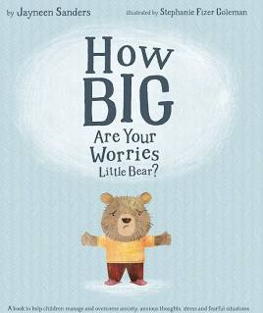
By Jayneen Sanders
Little bear is a worrier. He worries about everything! But with Mama Bear’s help, he soon learns his worries are not so big after all.
Through this engaging and beautifully illustrated story, children learn that everyday worries and fears can be overcome. It just takes a willingness to share with a helpful listener and an understanding that making mistakes is how we learn.

Hey Warrior!
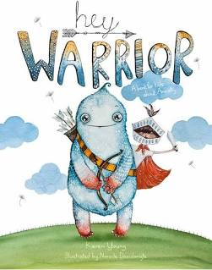
By Karen Young
A fantastic book to help children understand what actually happens in their brain when they experience anxiety. Kids can do amazing things with the right information. Understanding why anxiety feels the way it does, and where the physical symptoms come from, is a powerful step in turning anxiety around.

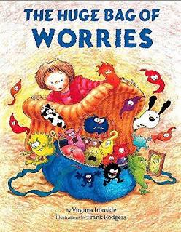
The Huge Bag of Worries
Virginia Ironside
Wherever Jenny goes, her worries follow her -in a big blue bag. Jenny decides they will have to go. But who can help? A great book to use with anxious children as it helps sort worries through and make them more manageable.

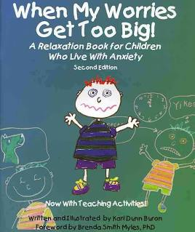
When My Worries Get Too Big.
By Kari Dunn Buron
Through the irresistible character of Nicholas, this book gives young children an opportunity to explore with parents or teachers their own feelings as they react to events in their daily lives while learning some relaxation techniques.

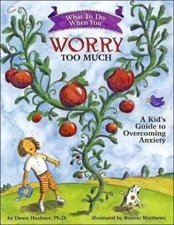
What to Do When You Worry Too Much
By Dawn Huebner
This book is an interactive self-help book designed to guide 6-12 year olds and their parents through the cognitive-behavioural techniques most often used in the treatment of generalised anxiety.

It’s Okay to Make Mistakes
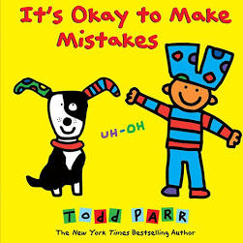
By Todd Parr
The book is suitable for younger children, embraces life’s happy accidents, the mistakes and mess-ups that can lead to self- discovery. Todd Parr brings a timely theme to life with his signature bold, Kid friendly illustrations and a passion for making readers feel good about themselves, encouraging them to try new things, experiment, and dare to explore new paths.

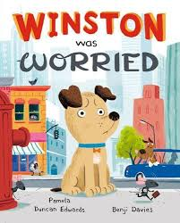
Winston was Worried
By Pamela Duncan Edwards
Poor Winston is far too worried to play with his friends. He’s off to the vet with a splinter in his paw, and there’s nothing worse than having a splinter in your paw. Or so Winston thinks…

